***SOFTWARE***

***REQUIREMENTS***

***SPECIFICATION***

***Patient Resource Software***

**Document ID:** 8723

**Author**: SHREE RAM V

**Version**: 2.0

**Date**: March 25, 2024

**INDEX**

1. Introduction

2. Scope

3. Functional Requirements

3.1 Patient Registration and Login

3.2 Educational Resources

3.3 Communication Tools

3.4 Appointment Scheduling

3.5 Health Metrics Tracking

4. Non-functional Requirements

4.1 Performance

4.2 Security

4.3 Usability

5. User Interface Design

6. System Architecture

**1. Introduction**

A web-based tool called Patient Resource Software was created to give patients access to resources and data about their medical need. The software seeks to enhance patient involvement, education, and communication with medical professionals.

**2. Scope**

The following functionalities will be included in the patient resource software:

* Sign-up and login for patients
* access to a variety of health-related publications, videos, and instructional materials
* Tools for messaging healthcare providers through communication
* Reminders and scheduling of appointments
* Monitoring health indicators and advancements
* Purchasing prescribed medicine
* One to one video interaction with doctors

**3. Functional Requirement**

**3.1 Patient Registration and Login**

* Users can create an account by providing their personal information, including name, email, and password.
* Users can log in using their email and password.

**3.2 Patient History And Tracking**

* User track their previous diagnosis history and schedules
* Provide a insight about user health

**3.3**  C**ommunication Tools**

* Users can send messages to healthcare providers for inquiries, appointment requests, or general communication.
* Healthcare providers can respond to messages from patients.

**3.4 Appointment Scheduling**

* Users can view available appointment slots and schedule appointments with healthcare providers.
* Users receive appointment reminders via email or SMS.

**3.5 Health Metrics Tracking**

* Users can input and track health metrics such as weight, blood pressure, and glucose levels.
* Users can view graphical representations of their health metrics over time.

**3.6 Buy Medicine**

* Existing User can able purchase prescribed medicines through online
* Get documentation on medicined with generated bill

**3.6 Video Counseling**

* One to one video session with doctor for betterment of patient
* Patient can interact with doctor on video calls

**4. Non-functional Requirements**

**4.1 Performance**

* The software should respond quickly to user actions, with minimal latency.
* The system should be able to handle concurrent user sessions without significant performance degradation.

**4.2 Security**

* **User data should be encrypted during transmission and storage.**
* **Access to patient data should be restricted based on user roles and permissions.**

**4.3 Usability**

* The user interface should be intuitive and easy to navigate, catering to users of all ages and technical abilities.
* The software should be accessible to users with disabilities.

**5. User Interface Design**

* The user interface should feature a clean and modern design, with clear navigation and consistent layout.
* Visual elements should be used to enhance usability, such as icons, buttons, and color-coded categories.

**6. System Architecture**

* The software will be built using a client-server architecture, with a web-based frontend and a backend server.
* The backend will be developed using Node.js and MongoDB for data storage.
* The frontend will be developed using HTML, CSS, and JavaScript, with responsive design for compatibility across devices.

**7.Flowchart**

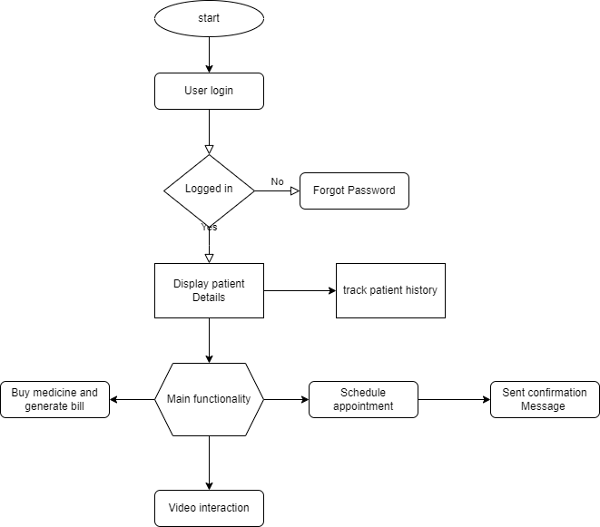

**8.Summary**

According to the Software Requirements Specification (SRS), the patient resource software is a powerful and user-focused tool designed to improve patient education, engagement, and healthcare administration. The software aims to enable patients to actively participate in their health and wellness journey while promoting smooth communication and collaboration with healthcare providers by providing a comprehensive suite of features and functionalities.

The software solves important pain points in the healthcare ecosystem, optimising workflows and enhancing patient outcomes. Features include patient registration, access to educational materials, messaging healthcare providers, appointment scheduling, and tracking health metrics.